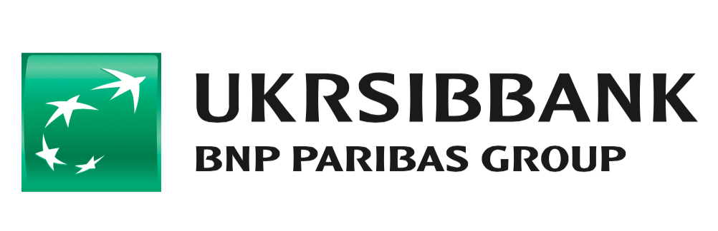
UKRSIBBANK, part of BNP Paribas Group, announces a strategic partnership with financial wellbeing startup Dreams, to enhance the digital user experience of its 2 million customers in Ukraine

- The technology powering popular consumer app, Dreams - which has helped 460,000 users save over 440M EUR - will be made available to UKRSIBBANK’s users in Ukraine.
- Through the integration of the Dreams platform within UKRSIBBANK’s own digital tools, customers of the bank can set and achieve money-saving goals, track and improve their financial lives.

12.11.20 - Stockholm, Sweden: Dreams (https://www.getdreams.com/en/b2b/), the Stockholm-born fintech empowering millennials to save and feel better about their money, today announces a strategic partnership with Ukrainian commercial bank UKRSIBBANK, a subsidiary of French international bank BNP Paribas Group.

This partnership follows the announcement earlier this year of Dreams’ first enterprise partnership with banking software provider Silverlake Symmetri, and the recent unveiling of a new department in Stockholm dedicated to the development of Dreams’ B2B partnerships. The announcement marks an expansion of the company’s business model as it consolidates its B2B offering and evolves its services as a provider of digital solutions for financial institutions.

Through the integration within UKRSIBBANK’s own digital tools of the Dreams Platform – which is rooted in scientific principles – customers can set and achieve money-saving goals through clever, automated saving features, in addition to nudges and saving hacks.

The Dreams Platform will be included as part of UKRSIBBANK’s digital banking offering for its 2 million+ customers, and is set to grant millions of potential consumers across Ukraine access to products which will help keep their finances on track and improve their financial lives.

The rise in digital self-help tools has long been anticipated by Dreams and forward-thinking financial institutions. The current global economic uncertainty brought about by the COVID-19 pandemic has also placed significant strains on people’s finances, and the demand for better personal finance tools has only accelerated. The partnership with Dreams is welcomed by UKRSIBBANK which is currently striving to equip its customers with the best possible banking solutions whilst helping them achieve a more sustainable lifestyle.

Dreams is firmly established as an authority in its industry, having launched its consumer-facing app in its native Sweden in 2016 and Norway in 2018 – where it has already achieved a 16% market share of all 20-39 year olds.

Henrik Rosvall, CEO and founder of Dreams, comments: “It’s a true honour to be partnering with UKRSIBBANK and BNP Paribas Group, and we’re incredibly excited to be introducing the Dreams solution to UKRSIBBANK’s customers and the wider Ukrainian market.

“Dreams and UKRSIBBANK can now lead the charge, with BNP Paribas Group’s corporate strategy having shifted in recent years to focus on guiding customers towards responsible consumption and sustainable personal finance management. I’m confident that our mission of helping millennials save more and feel better about their money makes us the ideal partners.

“Our financial wellbeing platform – which is built upon behavioural science and personal finance management principles – will provide the perfect tool for UKRSIBBANK to help its customers make better financial choices and become more sustainable in the way they handle their finances. This partnership will also help UKRSIBBANK safeguard the loyalty of its customers and futureproof its digital banking offering against a growing number of challenger banks and fintechs.”

Konstantin Lezhnin, Head of Retail at UKRSIBBANK BNP Paribas Group, comments: "I believe that banks have a role to improve their customers' lives. Planning and saving for important life events improves our quality of life by reducing stress levels, and we wish to make our customers feel more confident and in-control of their lives.

“UKRSIBBANK has always applied innovative ways to assist our customers in financial planning, so we are very happy to now be working with Dreams, the best European player in behavioural savings. They have an extremely solid track record in Sweden and Norway based on scientific research, so we are confident that this partnership will work positively for our customers in Ukraine. This also demonstrates our strategy to cooperate with startups and innovative companies that seek ways to expand their operations.”

About UKRSIBBANK
UKRSIBBANK BNP Paribas Group has been operating in the Ukrainian market since 1990, with a driving mission of making their customers’ financial lives simple, safe and rewarding.

The Bank offers high-quality financial solutions according to the best European financial services. 60% of the bank’s shares belong to one of the largest financial groups in the world – BNP Paribas, and 40% to EBRD.

The bank serves more than 2M customers, and 168,000 SME and corporate companies – 30% of the IT market in Ukraine, the leaders of the local Ukrainian economy. UKRSIBBANK also actively creates a favourable environment for the development of technological solutions: Battles of Startups, Pop-corp accelerator, and constant interactions with the IT Association of Ukraine.

About Dreams
Dreams was created to improve the financial wellbeing of an entire generation. While major banks continue to offer complex, impersonal savings and investments, the arrival of a new wave of easy, one-click credit has left a generation living from paycheck to paycheck.

Dreams is a unique platform, designed to give millennials a simple way to achieve their goals and ambitions, and improve their financial wellbeing. Rooted in cognitive science and behavioural economics, Dreams is as much a science company as a tech company. With a pipeline directly from academia to app, the company has already helped over 460,000 users save over 440M EUR.

Dreams was set up in 2014, and currently employs a diverse team of 80 employees from 15 different countries, in its Stockholm HQ and offices in Oslo and Berlin. In 2020, Dreams was recognised by CB Insights as one of the best fintech startups in the world. For more information about Dreams, please visit: www.getdreams.com

About BNP Paribas Group
BNP Paribas is a leading bank in Europe with an international reach. It has a presence in 71 countries, with approximately 199,000 employees, of which more than 151,000 in Europe. The Group has key positions in its three main activities: Domestic Markets and International Financial Services (whose retail-banking networks and financial services are covered by Retail Banking & Services) and Corporate & Institutional Banking, which serves two client franchises: corporate clients and institutional investors. The Group helps all its clients (individuals, community associations, entrepreneurs, SMEs, corporates and institutional clients) to realise their projects through solutions spanning financing, investment, savings and protection insurance.

In Europe, the Group has four domestic markets (Belgium, France, Italy and Luxembourg) and BNP Paribas Personal Finance is the European leader in consumer lending.

BNP Paribas is rolling out its integrated retail-banking model in Mediterranean countries, in Turkey, in Eastern Europe and a large network in the western part of the United States. In its Corporate & Institutional Banking and International Financial Services activities, BNP Paribas also enjoys top positions in Europe, a strong presence in the Americas as well as a solid and fast-growing business in Asia-Pacific.

For UK, US and other English-language media enquiries please contact Deliberate PR:
Matthew Lloyd / Andy O’Keeffe
matthew@deliberate-pr.com / andy@deliberate-pr.com
+44 7533 116 062 / +44 752 879 2790

For Ukrainian and Russian media enquiries please contact Ukrsibbank:
Tetiana Shykeriava / Nataliia Osadcha
tetiana.shykeriava@ukrsibbank.com / nataliia.o.osadcha@ukrsibbank.com
+380672431723 / +380685152240

